Nested Loops Practice

Pattern Builder Lab

# Main Objectives

* Build a skillset to manipulate nested loops.
* Logic building.

# Prior Knowledge

Students need to know how to write basic nested loops and will build on that knowledge with these exercises. The project needs almost no knowledge of Greenfoot: just the capability of building and placing an object at a specific location.

# Getting Started

Install the Greenfoot IDE: <https://www.greenfoot.org/download>

* Greenfoot went through many changes beginning with the 3.0.0 release. Version 2.4.2, although older, tends to be one of the most stable versions but is missing a few of the newer additions.

In your Pattern Builder folder, run the project file with the Greenfoot icon to begin.

# Demonstration

View a sample demonstration of what the Pattern Builder lab could look like here:

<https://www.greenfoot.org/scenarios/23754>

# Student Goals

Each part of this lab is a separate exercise in building a specific picture by placing Walls on the screen using loops. Students are given a HEIGHT variable and a WIDTH variable to represent the current screen size. The questions are not in order of difficulty and not all require nested loops. Students will need to think through the necessary requirement to build each pattern.

* Small Added Challenge: Avoid adding two Walls in the same location.

## A – allMiddle. Build Walls on all areas except the outer border.

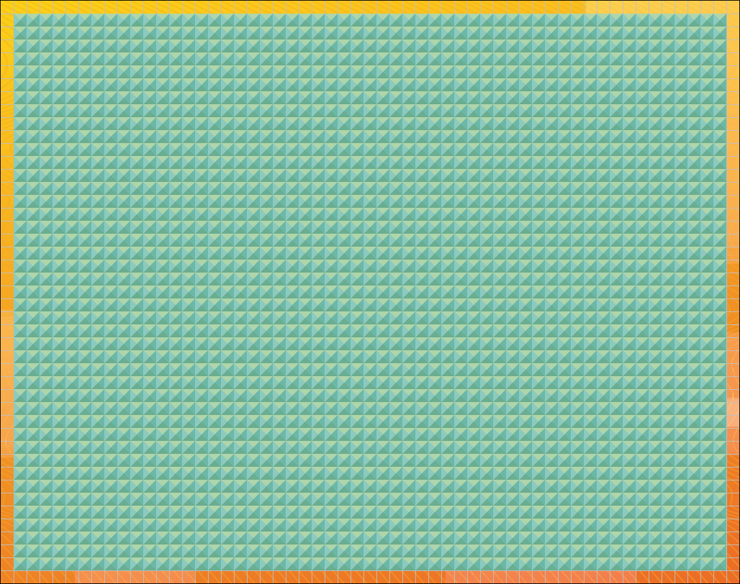

## B – border. Build Walls on only the outer border.

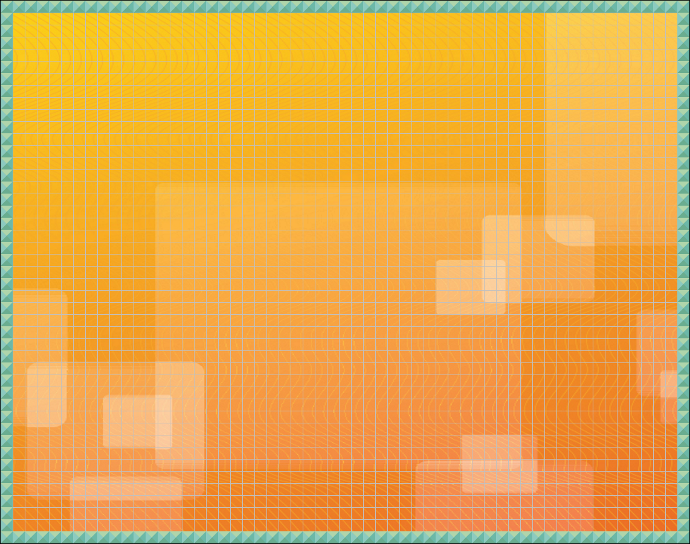

## C – checkered. Build walls on every other location to form a checker pattern.

## 

## D – diagonals. Build walls on two diagonal lines to form an X. The logic can be tricky if you want it to work on all sized worlds.

## 

## E – equator. Build Walls directly in the center of the World similar to an equator line.

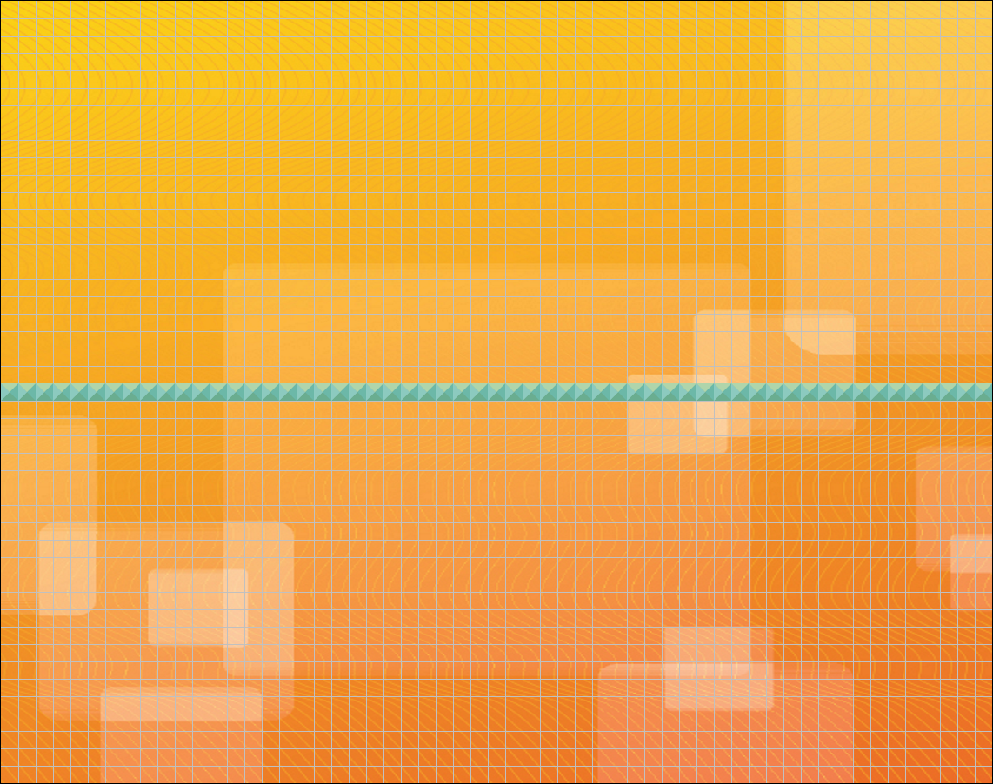

## F – fibonacci. Build Walls with the first two rows starting with only 1 Wall each, then every row afterwards will have the sum of the previous two row’s number of Walls. Due to the Fibonacci sequence growing so quickly skip some rows between.

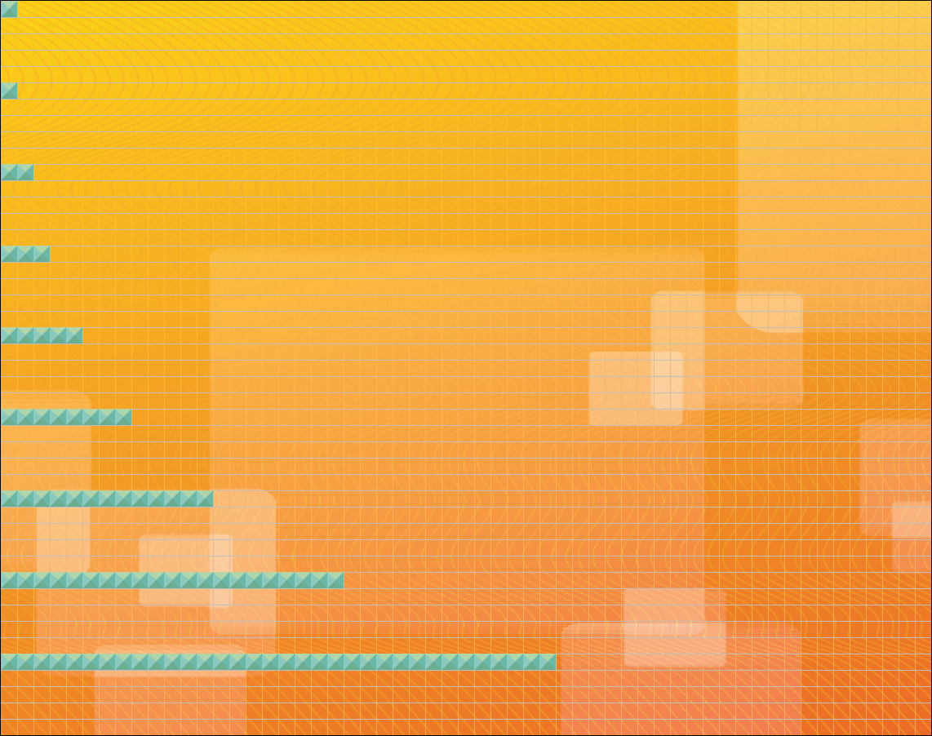

## G – geometricSeries. Build Walls with the first row having only 1 Wall and each subsequent row having twice as many Walls as the last. Due to how fast these numbers grow skip some rows between.

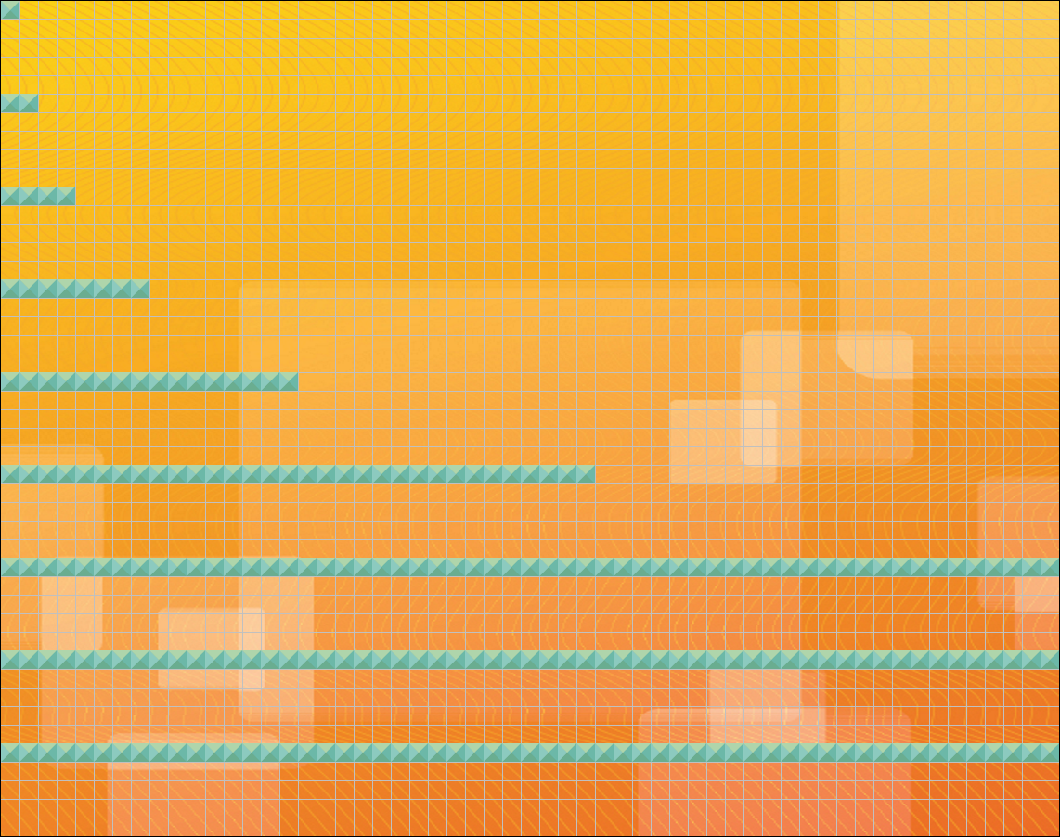

## H1 – hemisphereLeft. Build Walls to cover the left half of the World.

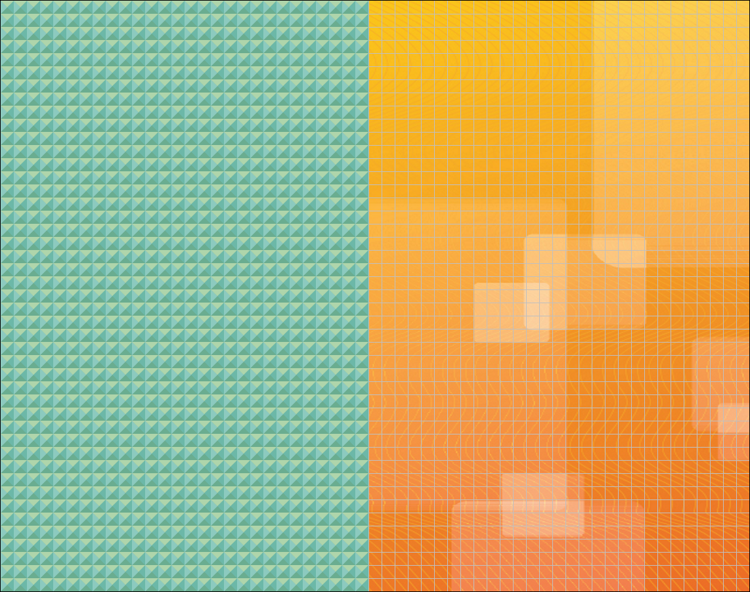

## H2 – hemisphereRight. Build Walls to cover the right half of the World.

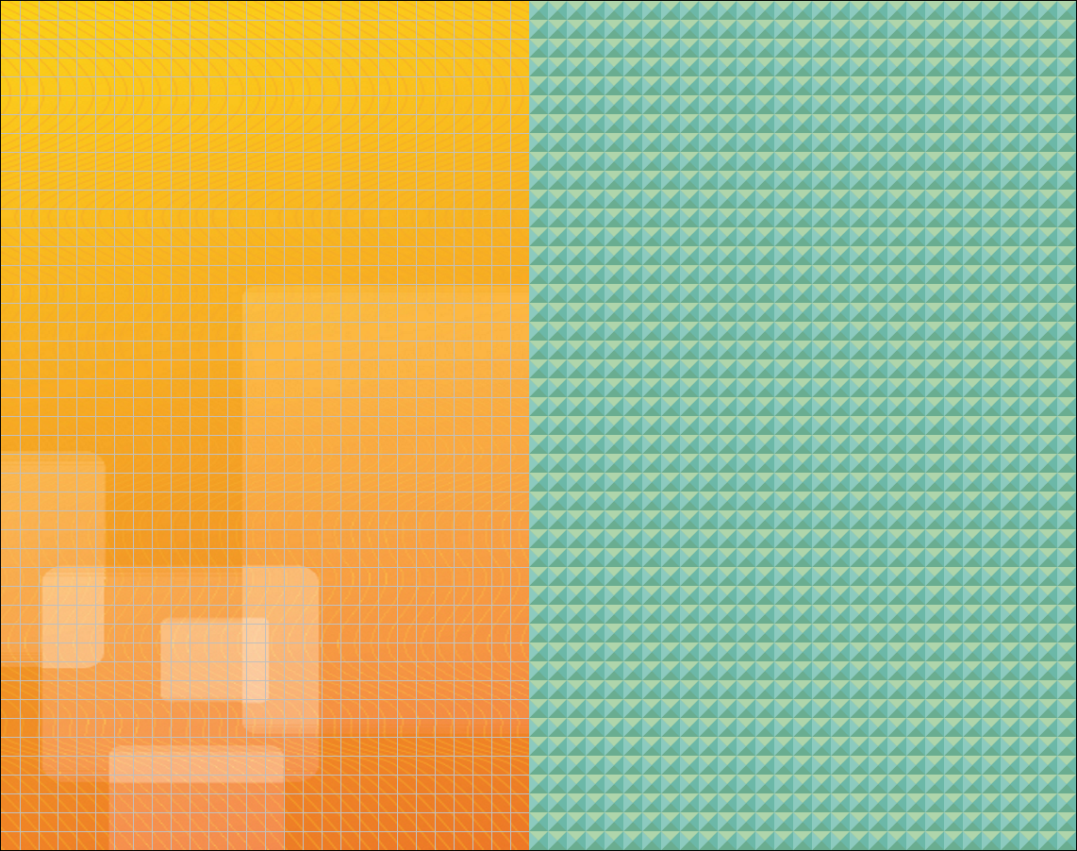

## H3 – hemisphereTop. Build Walls to cover the top half of the World.

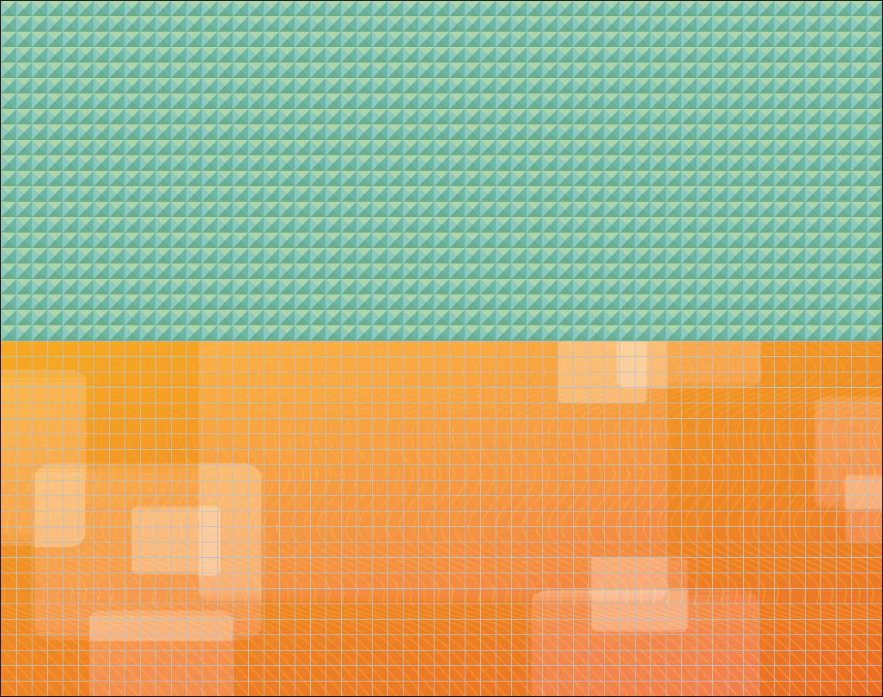

## H4 – hemisphereBottom. Build Walls to cover the bottom half of the World.

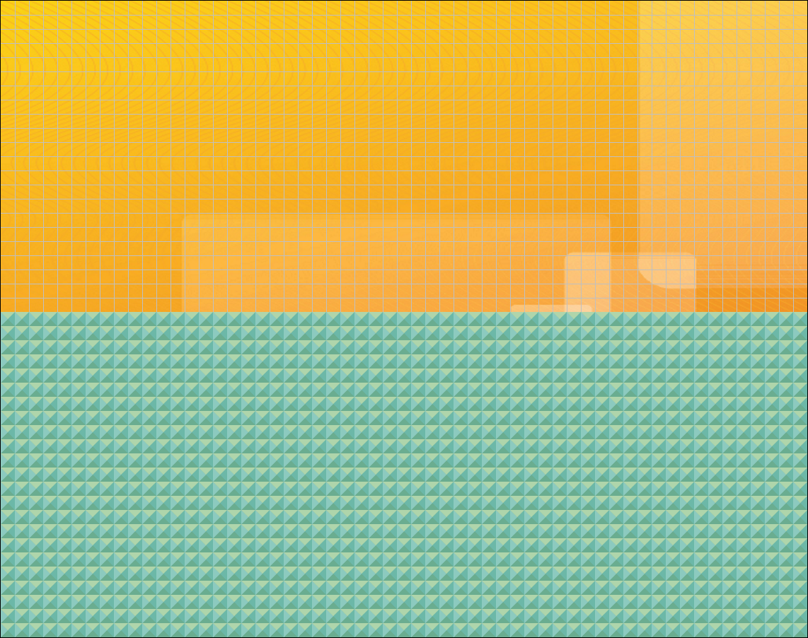

## I1 – isoscelesRightA. Build Walls to build a right isosceles triangle with the hypotenuse on the bottom right.

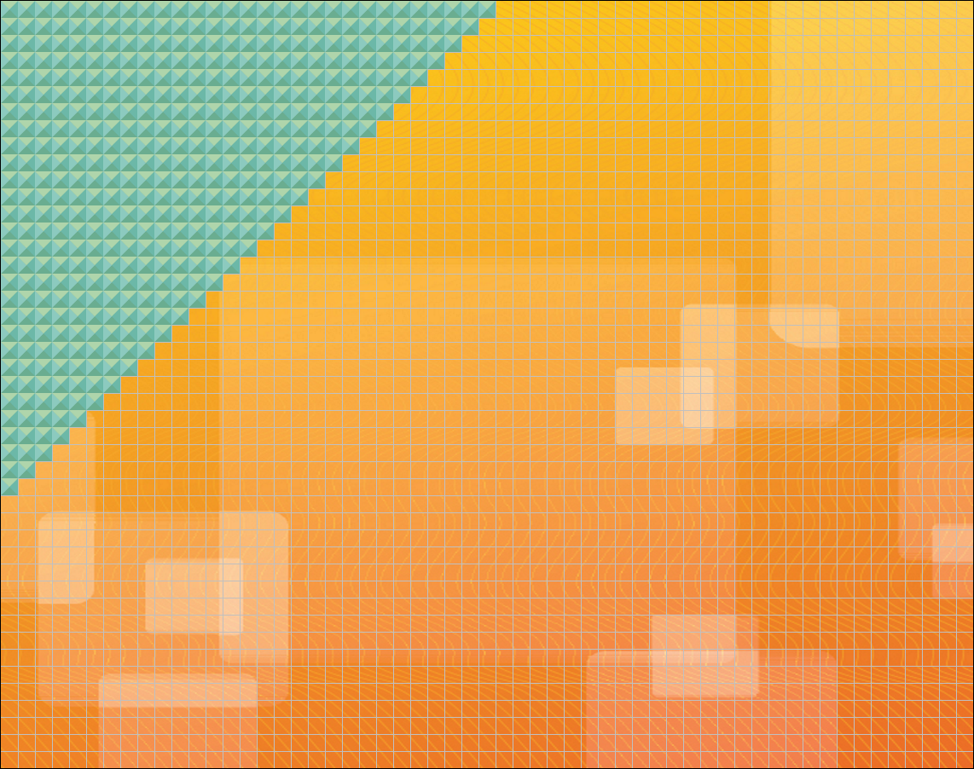

## I2 – isoscelesRightB. Build Walls to build a right isosceles triangle with the hypotenuse on the bottom left.

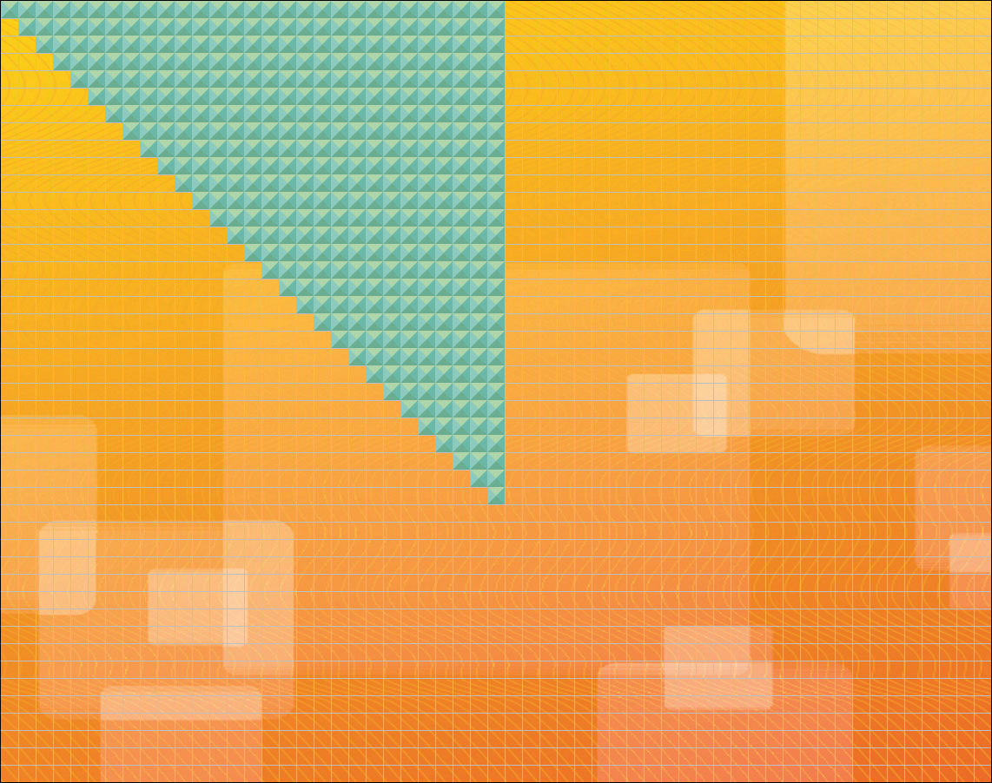

## I3 – isoscelesRightC. Build Walls to build a right isosceles triangle with the hypotenuse on the top right.

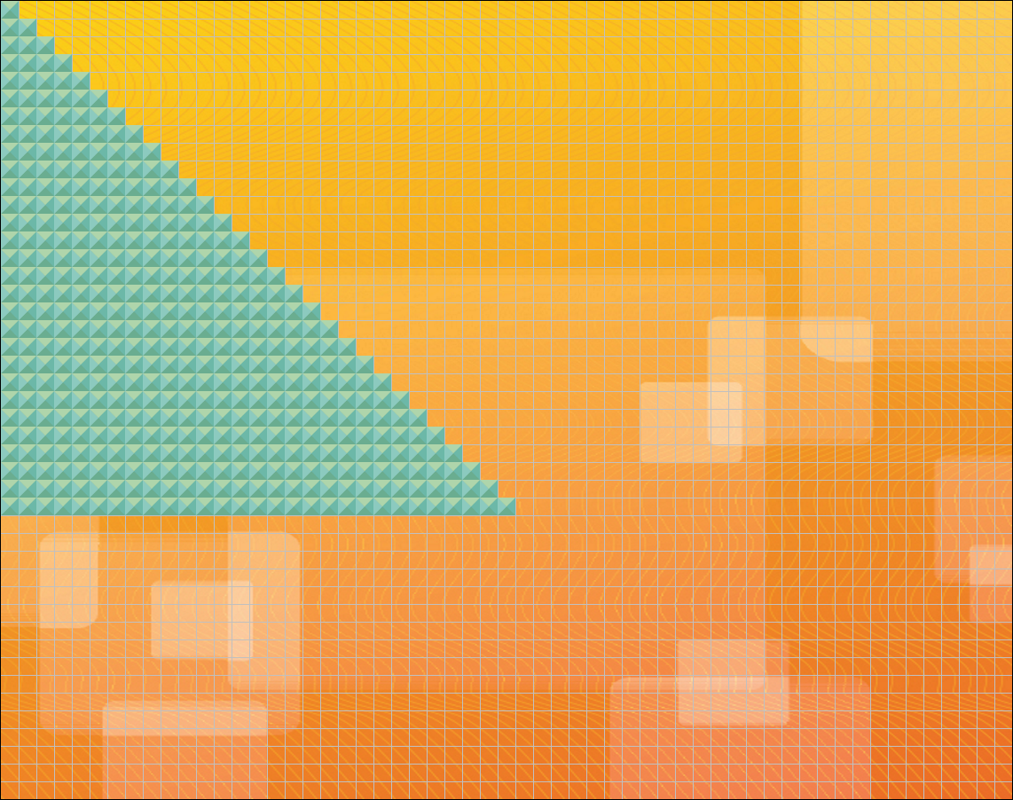

## I4 – isoscelesRightD. Build Walls to build a right isosceles triangle with the hypotenuse on the top left.

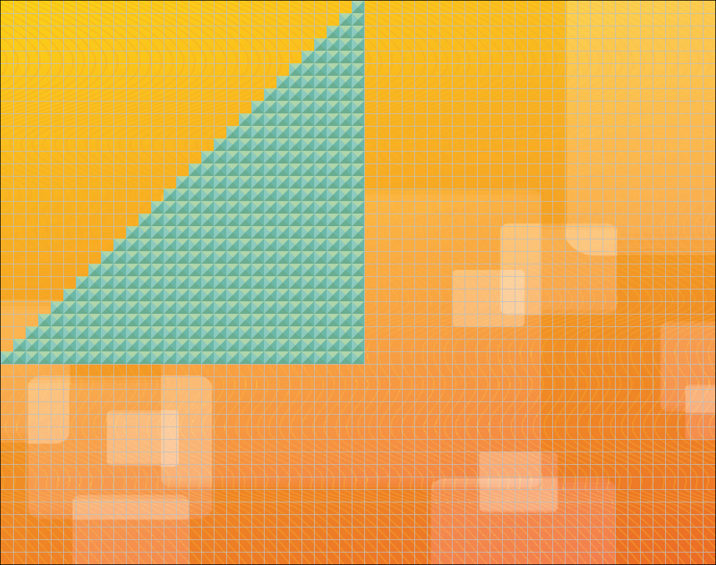

## J – jaggedSteps. Build Walls to make steps alternating either the ending missing a Wall or the beginning missing a Wall on each row.

